TASK 5
Analytics Report & Insights Documentation
Where taxi revenue comes from, and what to do about it
Data Science Internship Report
Submitted by: [Your Full Name]
November 2026

1. Executive summary
Business question. A taxi operator wants to know when, where and on what kinds of trips it earns the most, so it can put drivers and attention in the right places.
What I analysed. A public sample of 6,433 New York City taxi trips from March 2019 (6,304 after cleaning), covering yellow and green cabs.
Headline findings
- Total revenue in the sample was $115,363, an average of $18.3 per trip over 3.01 miles and 14.4 minutes.
- Demand peaks at 6 pm (416 trips), and 5 pm to 9 pm alone accounts for 30.2% of all trips.
- Earnings per minute are best in the early morning (about $1.87 at 5 am) and worst in mid-morning and early afternoon (about $1.22), when traffic slows cabs to roughly 10 mph.
- Short trips under 2 miles are 58.1% of trips but only 37.1% of revenue, while trips of 8 miles or more are 8.9% of trips and bring in 25% of revenue.
- Manhattan generates 82.7% of pickups, but Queens pickups are worth almost twice as much per trip ($31.34 vs $16.59).
- No tips are recorded for cash payments at all, so tip analysis is only reliable for card trips.
Top recommendations: (1) match driver supply to the 5 pm to 9 pm peak, (2) pilot more early-morning coverage, where each minute earns the most, (3) give drivers guidance on higher-value Queens and long-distance trips, and (4) fix how cash tips are captured. Details and priorities are in Section 7.

2. Business objectives and key questions
Before looking at the data I wrote down the questions a fleet manager would actually ask, so the analysis stayed focused on decisions and not on interesting-but-useless statistics.
- How much revenue is there, and what does a typical trip look like?
- At what times of day and days of the week is demand highest, and when is a driver’s time best paid?
- Which areas and which kinds of trips matter most for revenue?
- How do customers pay, and what does that mean for tips?
- What should the business do differently as a result?

3. Data and preparation
Each row is one trip with pickup and dropoff time, passenger count, distance, fare, tip, tolls, total, cab colour, payment type and pickup and dropoff zone and borough. I removed 129 rows (about 2%) with missing location or payment data, trips with zero distance or zero duration, and trips with implausible speeds above 80 mph. I then created duration in minutes, speed, hour of day, day of week, tip percentage, and revenue per mile and per minute.
Two limits to keep in mind throughout: this is a sample from one month, so patterns may not hold in other seasons, and the data has no cost information (fuel, driver pay, waiting time), so I measure revenue, not profit.

4. Key metrics
Metric | Value
Trips analysed | 6,304
Total revenue (fare + tip + tolls) | $115,363
Average total per trip | $18.3
Average fare (before tip and tolls) | $12.87
Average distance | 3.01 miles
Average duration | 14.4 minutes
Single-passenger trips | 72.6%
Card vs cash | 71.8% card / 28.2% cash
Yellow vs green cabs | 84.9% / 15.1% of trips

5. Findings

5.1 Time of day: volume and value tell different stories
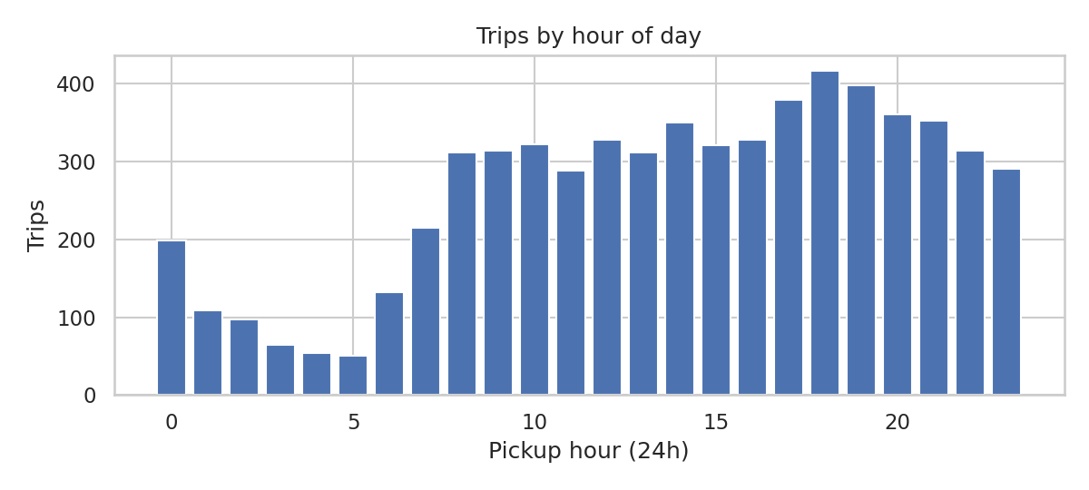
Figure 1. Trips by hour of day.
Trip counts climb through the day and peak at 6 pm with 416 trips. The quietest hour is 5 am with only 50. If you stopped here you would conclude that the evening is the place to be and 5 am is a waste of time.
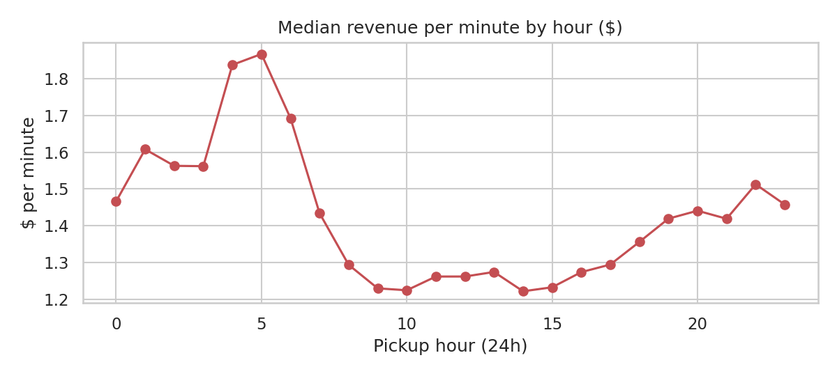
Figure 2. Median revenue per minute by hour. The early morning pays the most per minute.
But per minute worked, the picture reverses. Median revenue is highest at 5 am ($1.87 per minute), 4 am ($1.84) and 6 am ($1.69), and lowest at 2 pm, 10 am and 9 am (about $1.22). The explanation is in the speed data: cabs average about 19.2 mph at 5 am versus roughly 10 mph between 8 am and 6 pm.
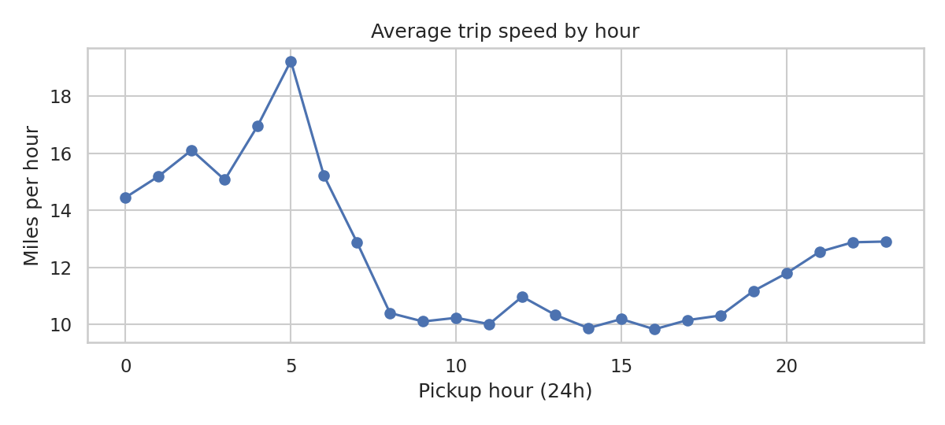
Figure 3. Average trip speed by hour. Daytime congestion roughly halves speed.
The average trip at 5 am is also the most valuable of the day ($24.07), which is consistent with longer trips on empty roads. The weakness of this finding is volume: with only 50 trips in that hour, the sample is thin, and a driver may wait longer between fares than the per-minute figure suggests.

5.2 Day of week
Friday is the busiest day (1085 trips), followed by Saturday (1019) and Wednesday (952). Monday is the quietest (698). The spread between best and worst day is about 55%, which is large enough to matter for scheduling. With one month of data, I would not read much into small differences between mid-week days.

5.3 Geography
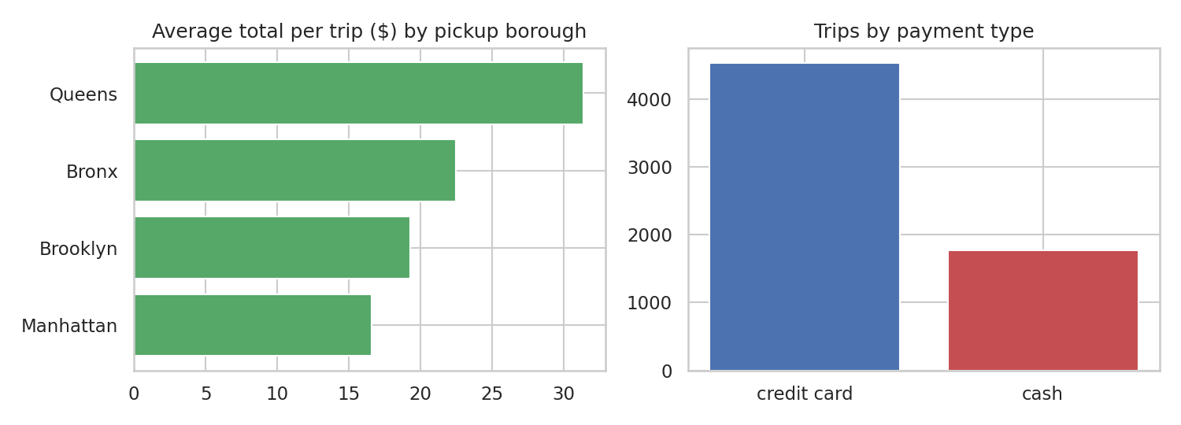
Figure 4. Average total per trip by pickup borough, and trips by payment type.
Pickup borough | Share of pickups | Avg total per trip | Median $ per minute
Manhattan | 82.7% | $16.59 | $1.4
Queens | 9.9% | $31.34 | $1.31
Brooklyn | 5.9% | $19.29 | $1.06
Bronx | 1.5% | $22.46 | $0.91

Manhattan dominates volume, and it also earns the most per minute ($1.4), probably because trips are short and quick to turn around. Queens trips are worth far more each ($31.34), which most likely reflects longer journeys, but the data cannot confirm the reason, and zone-level data would be needed to check that. The Bronx and Brooklyn are the weakest on both measures. The busiest pickup zones are Midtown Center (226 trips), Penn Station/Madison Sq West (209) and Upper East Side South (208).

5.4 Trip length
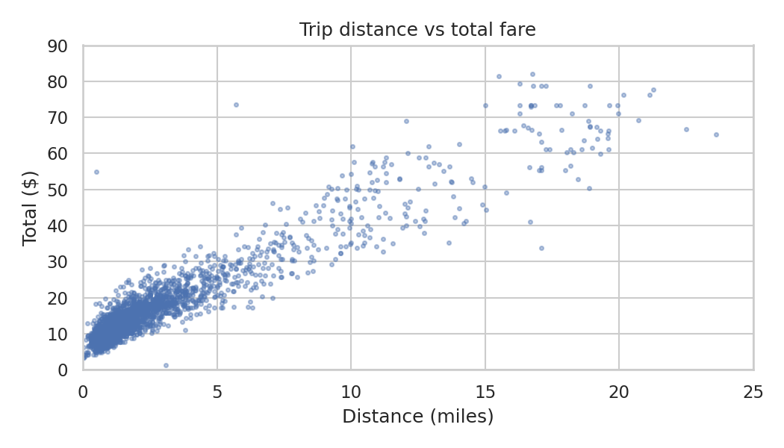
Figure 5. Distance versus total fare (sample of 2,500 trips).
Distance and total fare are almost perfectly linked (correlation 0.944), so fares behave predictably. The more interesting result is the mix: short trips under 2 miles make up 58.1% of trips and 37.1% of revenue, and long trips of 8 miles or more make up just 8.9% of trips but 25% of revenue. Short trips earn slightly more per minute ($1.54 vs $1.36) because of the fixed starting charge, while long trips earn far less per mile ($3.95 vs $10.73). Both have a role: short trips keep drivers busy, long trips deliver lumps of revenue.
Trips with tolls are only 5.3% of the total but average $55.49, about three times a normal trip.

5.5 Payment and tipping
71.8% of trips are paid by card. Among card trips, the average tip is 23.9% of the fare, and 9.7% of card trips have no tip. For cash trips, recorded tips are zero in 100% of cases, which almost certainly reflects how the data is collected (cash tips go straight to the driver and are not logged) rather than passengers not tipping. Any total-tip figure from this data therefore understates reality.

6. What the findings mean
- Supply and demand are mismatched in time. Drivers cluster when demand is visible (evening), but the best earnings per minute come when roads are fast. Operators who only chase volume leave money on the table.
- Mid-day is the weak spot. Slow traffic and the lowest revenue per minute make 9 am to 3 pm the least productive period, probably because fares are charged partly by time spent in traffic while distance is low.
- Revenue is concentrated. A small share of long trips and toll trips generates a big share of income, so missing a few of them costs more than missing many short ones.
- Measurement gaps limit decisions. Without cash tips and cost data, the business cannot see true driver earnings or profit.

7. Recommendations
# | Recommendation | Evidence | Priority | Next step
1 | Match driver supply to the 5 pm to 9 pm peak | 30.2% of trips occur in this window | High | Adjust shift start times; track wait times at Midtown and Penn Station
2 | Pilot extra early-morning (4 to 6 am) coverage | Highest $ per minute, fastest roads | Medium | Two-week pilot; measure idle time between fares
3 | Guide drivers toward higher-value Queens and long trips | Queens $31.34 vs Manhattan $16.59 per trip; long trips give 25% of revenue | Medium | Check zone-level detail to see which Queens trips drive this
4 | Reduce mid-day idle time | Lowest $ per minute at about 10 mph | Medium | Test shorter shifts or breaks in this window
5 | Capture cash tips and driver costs | Zero recorded cash tips; no cost data | High | Add a tip field to the cash workflow; add cost data to the dataset
6 | Encourage card payment | 71.8% already pay by card; tips average 23.9% | Low | Promote card-friendly terminals and prompts

8. Limitations and next steps
- Single month and a sample of trips; seasonality is unknown.
- Revenue only; no costs, so no profitability conclusions.
- The early-morning finding rests on few trips and should be treated as a hypothesis to pilot, not a rule.
- Next steps: repeat the analysis on a full year, add weather and event data, build a simple dashboard of hourly and zone-level metrics, and test recommendations with controlled pilots.

9. Appendix: reproducibility
Code: scripts/task5_taxi_analytics.py. Data: the public NYC taxi sample distributed with the seaborn-data repository (data/taxis.csv). All figures in this report are produced by that script.

